40.6: a) The wave function for 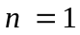 vanishes only at and 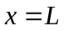 in the range 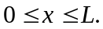 b) In the range for 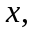the sine term is a maximum only at the middle of the box, 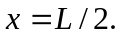 c) The answers to parts (a) and (b) are consistent with the figure.

